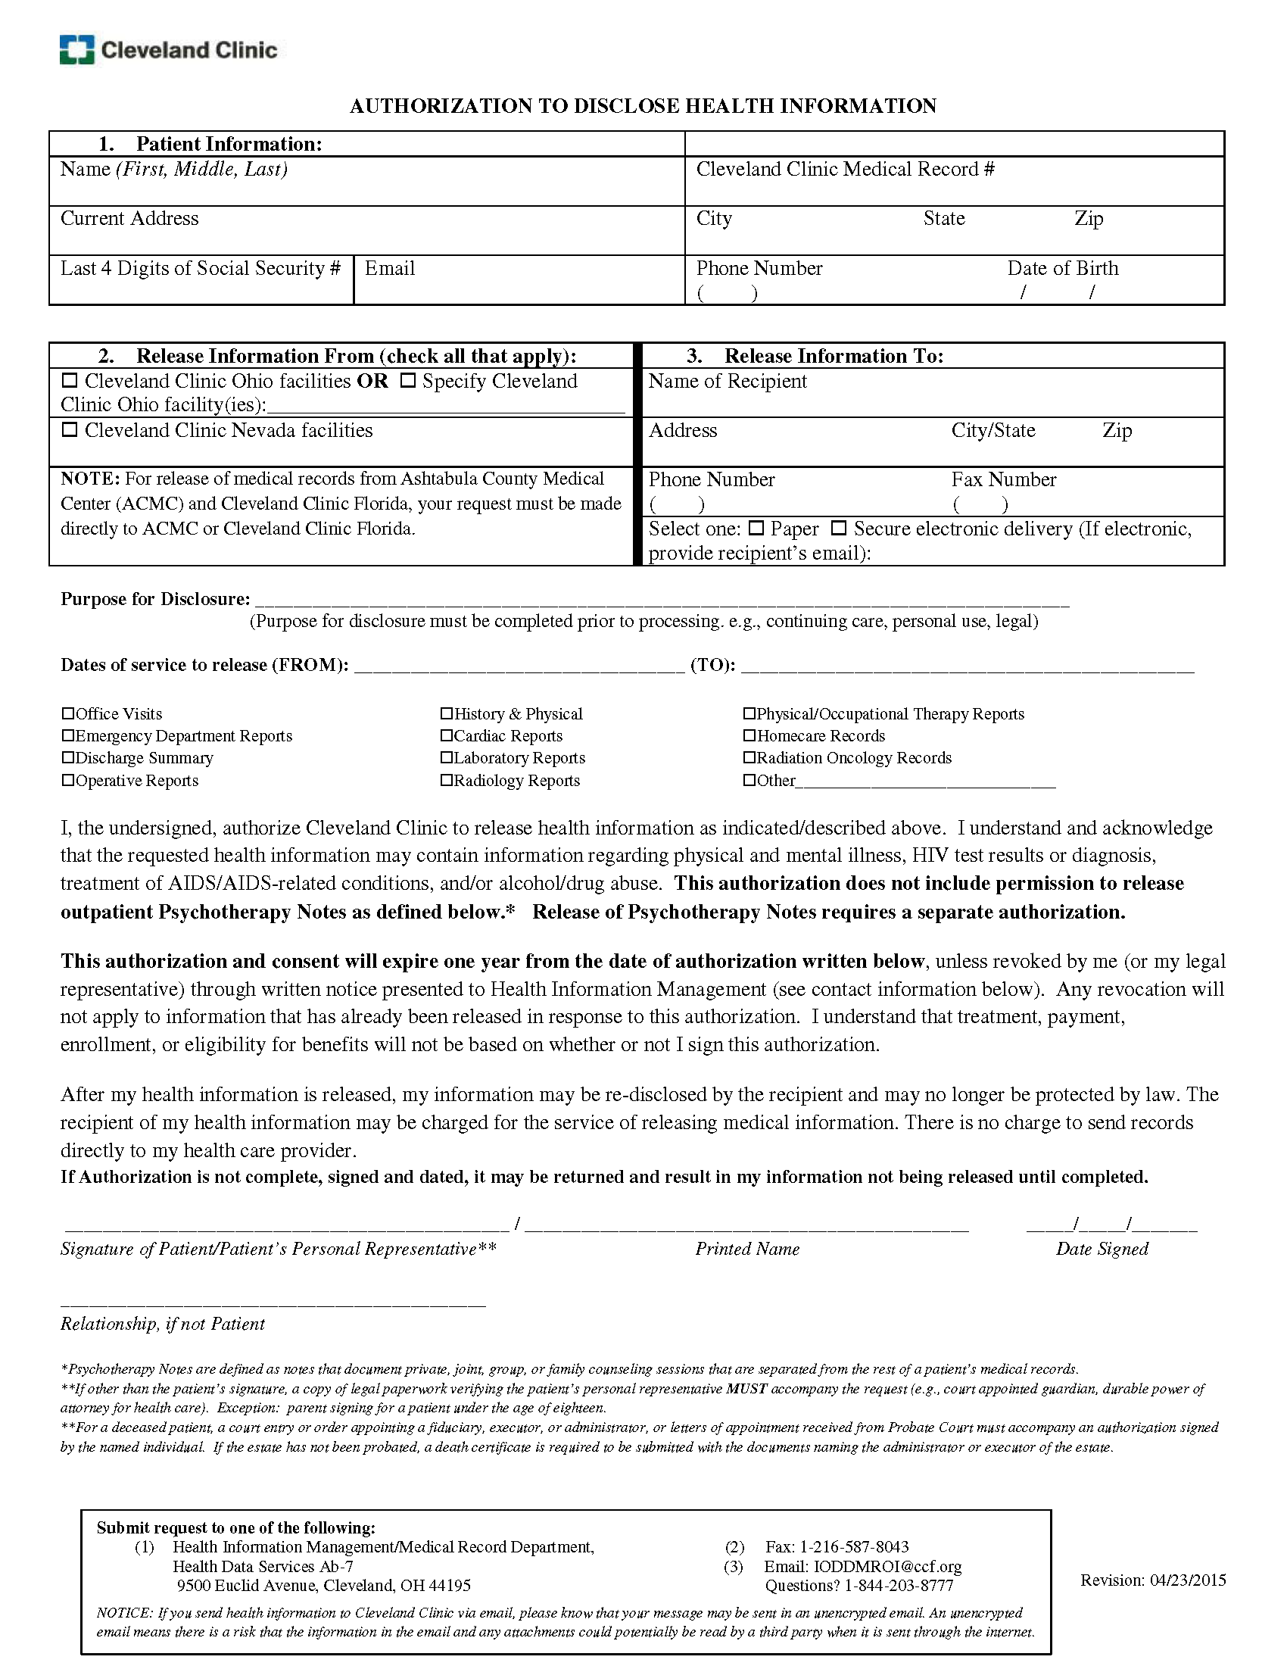
Batman
Secret Location Under Office Building
xxx-xx-5555
Gotham, NJ
01/01/1979
X
Axiom Requisition Copy Service
2869 Jolly Road Okemos/MI 48864
(877) 886-5090
Records@axiomcopy.com
(517) 886-4116
X
Litigation
FROM 01/01/1979 TO PRESENT: Any and all MEDICAL RECORDS, including but not limited to patient history form(s), reports, etc. pertaining to Batman SSN: xxx-xx-5555, DOB: 01/01/1979.
Order No: 01-29018-002

